**PROJECT REPORT**

1. **INTRODUCTION:**

The *ToyCraft Tales* project is focused on delivering interactive, insightful, and easy-to-use data visualizations for toy manufacturing industry data. In today’s data-driven world, industries and individuals alike need intuitive tools to make sense of complex datasets. This project leverages open-source technologies and cloud-based visualization tools to transform raw toy manufacturer data into meaningful visual insights.

Through this platform, users can explore market trends, production patterns, and regional distributions of toy manufacturers via dashboards, charts, and interactive stories. The application aims to make data analysis accessible to non-technical users, educators, small business owners, and hobbyists.

The project follows an agile development approach, covering ideation, design, requirement analysis, development, and testing phases. It combines Python’s Flask framework, ngrok tunneling, MySQL for data storage, and Tableau Public for embedding rich data visualizations into the application’s UI.

* 1. **Project Overview**

*ToyCraft Tales: Tableau’s Vision into Manufacturers Data* is a web-based application designed to present toy manufacturing data in an interactive and user-friendly way. The project integrates Flask (Python web framework) with Tableau Public dashboards and charts to visualize trends, production patterns, and regional distributions within the toy industry.

The application is accessed via ngrok, making it easy to share and view without complex deployment. Users can navigate between Home, Dashboard, Story, and Charts sections. A contact form allows interested users to join the initiative, storing their details in a MySQL database and sending them welcome emails.

The project’s goal is to enable non-technical users to gain valuable insights from complex datasets and support data-driven decisions in academic, business, or personal contexts.

* 1. **Purpose**

*ToyCraft Tales: Tableau’s Vision into Manufacturers Data* is a web-based application designed to present toy manufacturing data in an interactive and user-friendly way. The project integrates Flask (Python web framework) with Tableau Public dashboards and charts to visualize trends, production patterns, and regional distributions within the toy industry.

The application is accessed via ngrok, making it easy to share and view without complex deployment. Users can navigate between Home, Dashboard, Story, and Charts sections. A contact form allows interested users to join the initiative, storing their details in a MySQL database and sending them welcome emails.

The project’s goal is to enable non-technical users to gain valuable insights from complex datasets and support data-driven decisions in academic, business, or personal contexts.

1. **IDEATION PHASE**

The ideation phase of *ToyCraft Tales* focused on identifying the core problem, understanding the needs of potential users, and brainstorming a solution that bridges the gap between raw data and valuable insights. This phase included defining the problem statement, mapping user perspectives through an empathy map, and generating creative ideas that shaped the final solution concept.

**2.1 Problem Statement**

The toy manufacturing industry generates large amounts of data related to production, regional distribution, and market trends. However, this data is often scattered across different sources, available in static formats, or difficult to interpret without technical expertise.

Non-technical users — including educators, students, hobbyists, and small business owners — face challenges in accessing, understanding, and analyzing this data to gain meaningful insights. Existing solutions typically require manual data collection, advanced analytics tools, or technical skills that may not be widely available.

There is a need for an intuitive, interactive, and easy-to-access platform that transforms raw toy manufacturing data into visual insights to support decision-making and learning.

*Smartphone User with Low Storage Issues*

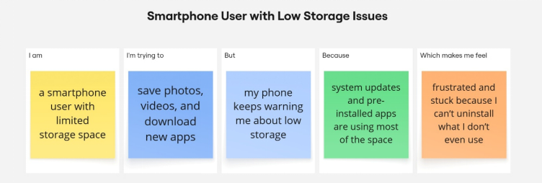

*Food Delivery Rider Managing in Heavy Rain*

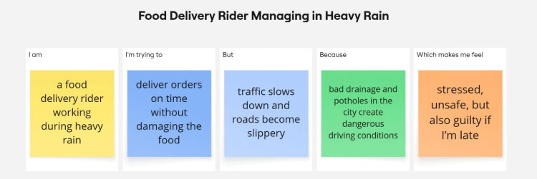

*Working Mom Trying in a Recipe*

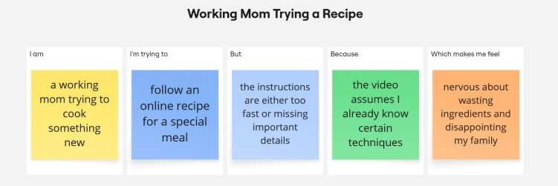

|  |  |  |  |  |  |
| --- | --- | --- | --- | --- | --- |
| **Problem Statement (PS)** | **I am** | **I’m trying to** | **But** | **Because** | **Which makes me feel** |
| PS-1: **Smartphone User with Low Storage Issues** | a smartphone user with limited storage space | save photos, videos, and download new apps | my phone keeps warning me about low storage | system updates and pre-installed apps are using most of the space | frustrated and stuck because I can’t uninstall what I don’t even use |
| PS-2:  **Food Delivery Rider Managing in Heavy Rain** | a food delivery rider working during heavy rain | deliver orders on time without damaging the food | traffic slows down and roads become slippery | bad drainage and potholes in the city create dangerous driving conditions | stressed, unsafe, but also guilty if I’m late |
| PS-3:  **Working Mom Trying a Recipe** | a working mom trying to cook something new | follow an online recipe for a special meal | the instructions are either too fast or missing important details | the video assumes I already know certain techniques | nervous about wasting ingredients and disappointing my family |

**2.2 Empathy Map Canvas**

To better understand the target users of *ToyCraft Tales*, an empathy map was created. This map reflects the thoughts, feelings, needs, and challenges faced by users interacting with toy manufacturing data:

* **Says:**  
  "I want to see clear trends without working through raw data."  
  "I need something easy to use without installing heavy software."
* **Thinks:**  
  "Is this data source reliable?"  
  "Will I be able to understand the charts and dashboards without expert help?"
* **Does:**  
  Accesses links shared by others (e.g., ngrok URLs), tries to explore data, fills out forms to participate or contribute.
* **Feels:**  
  Curious to explore toy industry data, sometimes unsure about technical tools, relieved when data is easy to interpret, satisfied after gaining insights.

The empathy map highlighted the importance of providing a lightweight, accessible, and visually rich tool that builds confidence and delivers immediate value to non-technical users.

|  |  |
| --- | --- |
| SAYS | THINKS |
| - "I want to see clear trends without working through raw data."  - "I need something easy to use without installing heavy software." | - "Is this data source reliable?"  - "Will I be able to understand the charts and dashboards without expert help?" |
| DOES | **FEELS** |
| - Accesses links shared by others (e.g., ngrok URLs)  - Tries to explore data  - Fills out forms to participate or contribute | - Curious to explore toy industry data  - Sometimes unsure about technical tools  - Relieved when data is easy to interpret  - Satisfied after gaining insights |

An empathy map is a simple, easy-to-digest visual that captures knowledge about a user’s behaviours and attitudes.

It is a useful tool to helps teams better understand their users.

Creating an effective solution requires understanding the true problem and the person who is experiencing it. The exercise of creating the map helps participants consider things from the user’s perspective along with his or her goals and challenges.

*Working Mom Trying a Recipe from YouTube.*

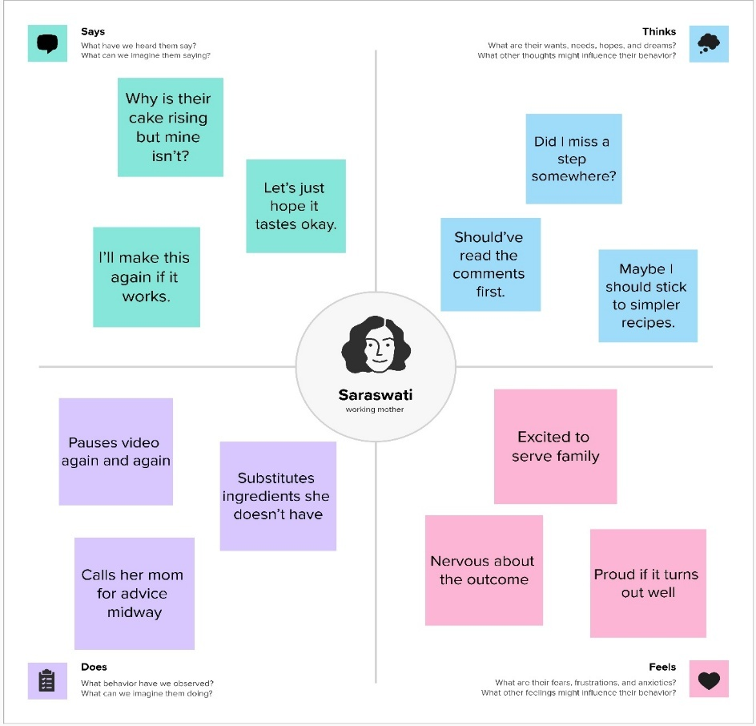

*Young School Teacher Managing Online and Offline Classes Together.*

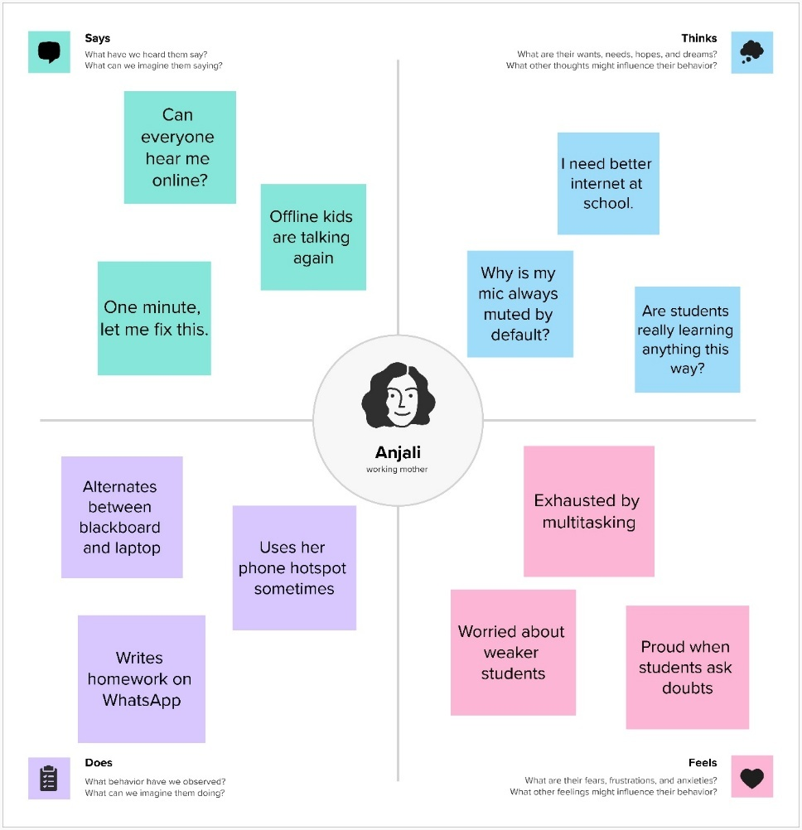

**2.3 Brainstorming**

During the ideation phase, several ideas were considered to address the problem of making toy manufacturing data accessible and insightful for non-technical users. The team explored solutions that would balance ease of use, low technical barriers, and meaningful data visualization.

Key ideas generated during brainstorming included:

* Building a web-based platform using Flask to avoid the need for complex installations.
* Using ngrok to easily share the app publicly without full cloud deployment.
* Embedding Tableau Public dashboards, charts, and stories for rich, interactive data visualization.
* Adding a simple contact form to engage users and build a community.
* Automating welcome emails to enhance user experience when valid details are submitted.
* Keeping the technology stack lightweight and focused on open-source or free tools to ensure accessibility.

These ideas were evaluated and refined to form the foundation of the proposed solution.

**Step-1: Team Gathering, Collaboration and Select the Problem Statement**

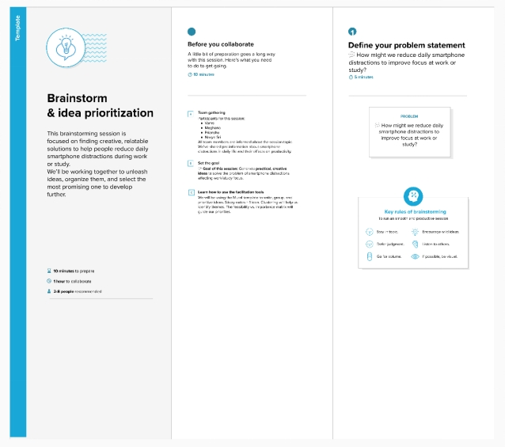

**Step-2: Brainstorm, Idea Listing and Grouping**

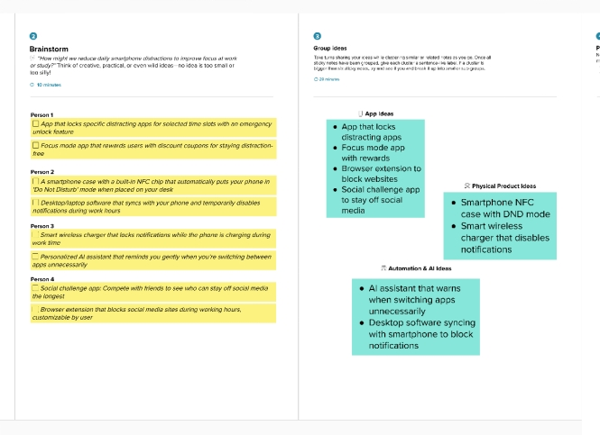

**Step-3: Idea Prioritization**

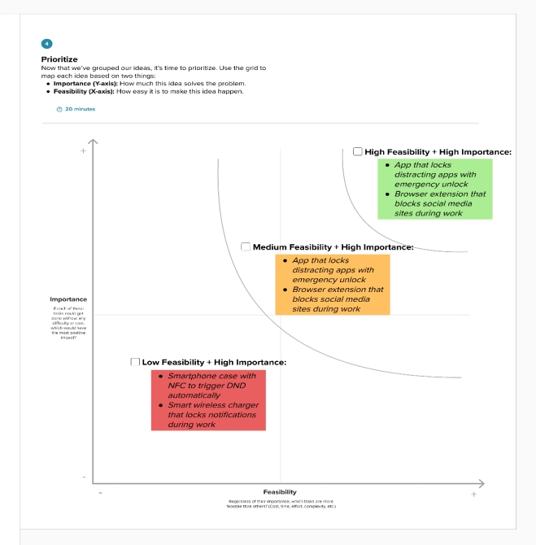

1. **REQUIREMENT ANALYSIS**

The requirement analysis phase focused on defining how *ToyCraft Tales* would meet the needs identified during ideation. This involved mapping the user experience, specifying solution requirements, designing the data flow, and selecting an appropriate technology stack.

The goal of this phase was to ensure that the proposed solution would provide a seamless, intuitive, and technically feasible experience for end users, while supporting the core functionalities of interactive visualization, data handling, and community engagement.

**3.1 Customer Journey Map**

The customer journey for *ToyCraft Tales* was designed to ensure an intuitive and engaging experience from first contact through sustained interaction. The key stages of the journey are as follows:

* **Entice:**  
  Users are introduced to the application through shared ngrok links, social media, or peer recommendations. They are motivated by curiosity about toy manufacturing data and the desire for easy, insightful exploration.
* **Enter:**  
  Users access the platform via a browser and arrive at the Home page, where they see clear options to explore the Dashboard, Charts, and Story. The navigation is simple to encourage further interaction.
* **Engage:**  
  Users explore interactive dashboards and charts, apply filters, and review story scenes to gain insights. They can also fill out the contact form to join the community, receiving a welcome email upon valid submission.
* **Exit:**  
  Users leave the platform with a sense of satisfaction from exploring data or having contributed their contact details. If they submitted the form, they are added to the community database for future updates.
* **Extend:**  
  Users may return via follow-up emails, recommendations, or bookmarking the ngrok link. They may share the tool with others or revisit to explore new insights.

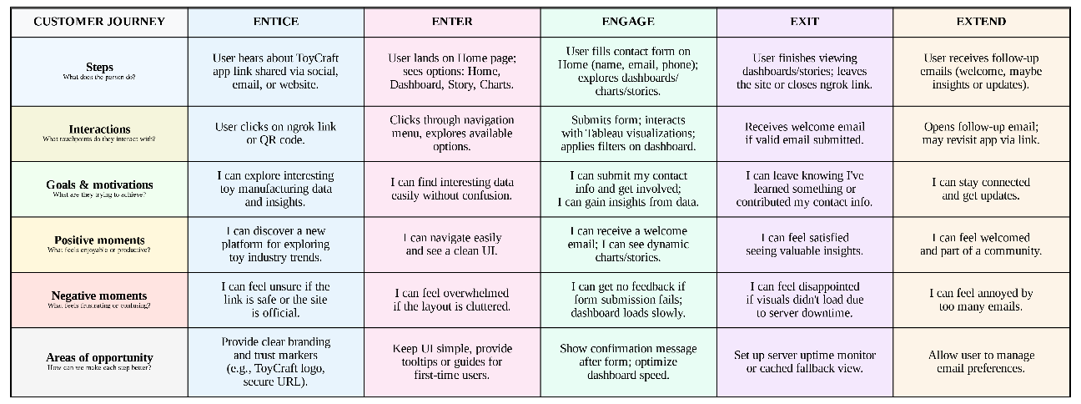The journey emphasizes ease of access, clarity in navigation, and interactive engagement to maximize satisfaction and usefulness.

**3.2 Solution Requirement**

The solution requirements for *ToyCraft Tales* were defined to ensure the application meets user needs effectively and delivers an interactive, reliable experience.

**Functional Requirements:**

* Provide a web-based platform accessible via ngrok link.
* Allow users to navigate between Home, Dashboard, Charts, and Story pages.
* Embed Tableau dashboards, charts, and stories for interactive data visualization.
* Enable users to submit contact information (name, email, phone) via a form.
* Send automated welcome emails for valid form submissions.
* Store contact data securely in a MySQL database.
* Allow admin-level access to view, manage, and monitor stored data and server status.

**Non-Functional Requirements:**

* The application should be easy to use and require minimal technical knowledge.
* The system should handle form validation efficiently and securely.
* The dashboards and charts should load quickly and update responsively to filter changes.
* The solution should be lightweight, scalable, and easy to maintain using open-source technologies.

These requirements guided the design and development of the solution to ensure both functional completeness and usability.

**Functional Requirements:**

|  |  |  |
| --- | --- | --- |
| **FR No.** | **Functional Requirement (Epic)** | **Sub Requirement (Story / Sub-Task)** |
| FR-1 | |  | | --- | |  |   Data Collection & Extraction | Import data from external databases  Perform SQL queries for data extraction  Schedule automated data refresh |
| FR-2 | Data Preparation | Clean and transform data for Tableau visualization Handle missing values and data type conversions  Create calculated fields and hierarchies |
| FR-3 | Data Visualization | View dashboards with interactive charts and graphs  Access stories showing market trends and insights  Filter visualizations by region, year, category |
| FR-4 | Data Upload & Integration | Upload new datasets to the system  Integrate with external database (e.g., SQL DB)  Connect Tableau dashboards to live data |
| FR-5 | Web Embedding | Embed Tableau dashboard in web app (Flask UI)  Provide responsive UI for dashboard interaction |
| FR-6 | Report & Export | Download reports as PDF or Excel  Export specific visualizations |

**Non-functional Requirements:**

|  |  |  |
| --- | --- | --- |
| **FR No.** | **Non-Functional Requirement** | **Description** |
| NFR-1 | **Usability** | The system should provide an intuitive and easy-to-navigate interface for both administrators and end users. Users should be able to interact with dashboards, filters, and reports without extensive training. |
| NFR-2 | **Security** | All data must be secured through encryption, with robust authentication and authorization mechanisms. The system should protect against unauthorized access and ensure data privacy. |
| NFR-3 | **Reliability** | The solution should perform consistently without unexpected failures or downtime. It must deliver accurate visualizations and data outputs at all times. |
| NFR-4 | **Performance** | Dashboards and reports should load quickly, ideally within 3 seconds for normal queries. The system should handle complex visualizations efficiently without lag. |
| NFR-5 | **Availability** | The platform should ensure 99.9% uptime, making dashboards and data accessible at all times except during scheduled maintenance. This helps maintain user trust and continuous data access. |
| NFR-6 | **Scalability** | The system should support growing data volumes and increased user load without performance degradation. It should be easy to scale horizontally or vertically as demand grows. |

**3.3 Data Flow Diagram and User Stories**

**Data Flow Diagrams:**

A Data Flow Diagram (DFD) is a traditional visual representation of the information flows within a system. A neat and clear DFD can depict the right amount of the system requirement graphically. It shows how data enters and leaves the system, what changes the information, and where data is stored.

**DFD:**

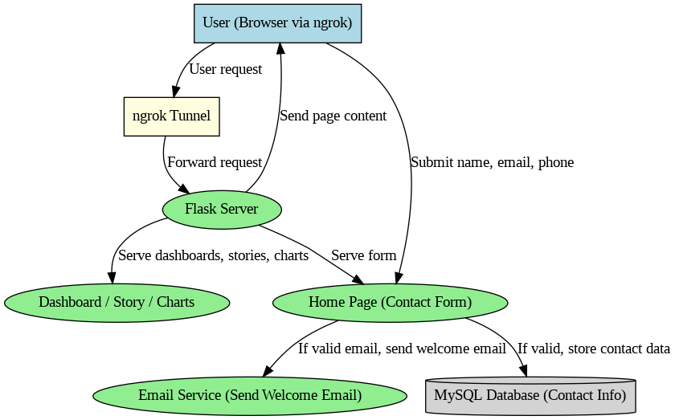

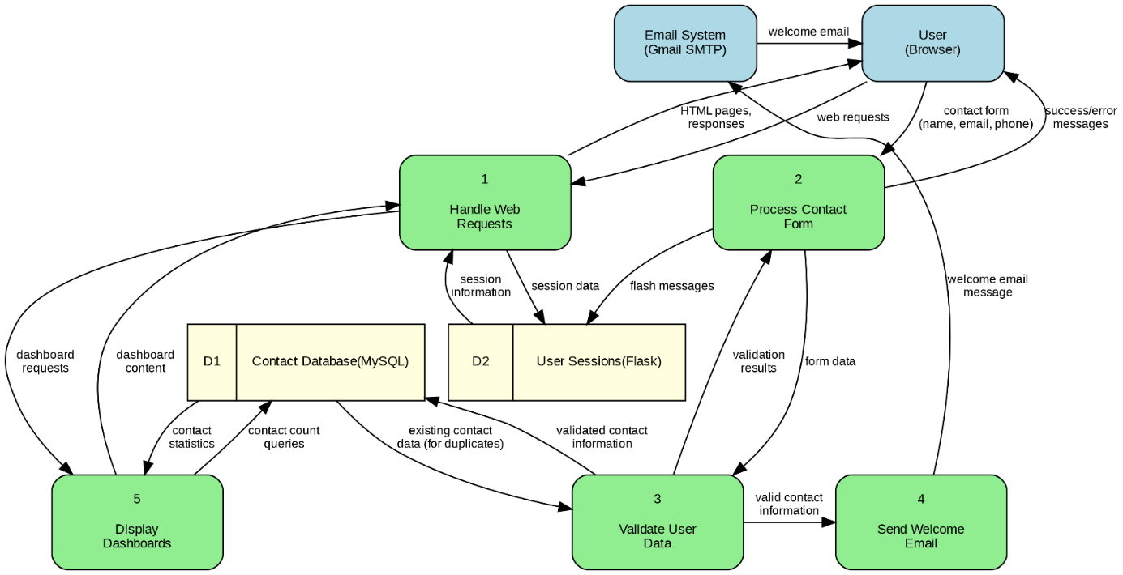

**User Stories**

Use the below template to list all the user stories for the product.

User Type: **Customer (Mobile user) / (Web user)**  
Functional Requirement (Epic): **Registration / Contact Form**  
**USN-1**  
User Story / Task: As a user, I can access the application via ngrok and view the Home, Dashboard, Story, and Charts options.  
Acceptance criteria: I can see and navigate between these options when the server is running.  
Priority: High  
Release: Sprint-1

**USN-2**  
User Story / Task: As a user, I can fill in my name, email, and phone number in the contact form to join the committee.  
Acceptance criteria: I can submit my details successfully to the server.  
Priority: High  
Release: Sprint-1

**USN-3**  
User Story / Task: As a user, if I submit a valid email, I will receive a welcome email from ToyCraft Tales.  
Acceptance criteria: I can receive a welcome email at my valid email address after form submission.  
Priority: Medium  
Release: Sprint-1

**USN-4**  
User Story / Task: As a user, if I submit an invalid email, no email will be sent, and my data will not be saved.  
Acceptance criteria: I can see that no email is sent and no data is saved when the email is invalid.  
Priority: Medium  
Release: Sprint-1

User Type**: Customer (Mobile user) / (Web user)**  
Functional Requirement (Epic): **Dashboard**  
**USN-5**  
User Story / Task: As a user, I can access the interactive dashboard from the menu and view visual insights.  
Acceptance criteria: I can view and interact with the dashboard (filters, tooltips, etc.).  
Priority: High  
Release: Sprint-1

**USN-6**  
User Story / Task: As a user, I can apply filters on the dashboard (e.g., by year, manufacturer, state) to refine the data view.  
Acceptance criteria: I can see the dashboard update dynamically based on the filters I apply.  
Priority: Medium  
Release: Sprint-2

User Type: Customer (Mobile user) / (Web user)  
Functional Requirement (Epic): **Charts**  
**USN-7**  
User Story / Task: As a user, I can access individual charts showing analyses such as Toy Manufacturers by Year or Top 10 States.  
Acceptance criteria: I can view the charts without errors and see relevant data visualizations.  
Priority: High  
Release: Sprint-1

**USN-8**  
User Story / Task: As a user, I can interact with chart elements (e.g., hover or click for details).  
Acceptance criteria: I can see detailed information when I hover over or click on chart elements.  
Priority: Low  
Release: Sprint-2

User Type: **Customer (Mobile user) / (Web user)**  
Functional Requirement (Epic): **Story**  
**USN-9**  
User Story / Task: As a user, I can access a Tableau story with multiple scenes showing toy industry trends.  
Acceptance criteria: I can navigate between story scenes without errors.  
Priority: High  
Release: Sprint-1

**USN-10**  
User Story / Task: As a user, I can navigate between story scenes and understand key insights from each scene.  
Acceptance criteria: I can see a clear title and summary of insights in each story scene.  
Priority: Medium  
Release: Sprint-2

User Type: **Customer Care Executive**  
**USN-11**  
User Story / Task: As a customer care executive, I can view contact form submissions stored in the MySQL database.  
Acceptance criteria: I can access a secure view of stored contact data.  
Priority: Medium  
Release: Sprint-2

User Type: **Administrator**  
**USN-12**  
User Story / Task: As an admin, I can manage (view, edit, delete) contact form submissions in the database.  
Acceptance criteria: I can update or delete records of contact submissions as needed.  
Priority: High  
Release: Sprint-1

**USN-13**  
User Story / Task: As an admin, I can monitor the availability of the server (Flask + ngrok status).  
Acceptance criteria: I can view or be alerted when the server is down or unreachable.  
Priority: Medium  
Release: Sprint-2

**3.4 Technology Stack**

The *ToyCraft Tales* solution uses a lightweight and accessible technology stack to support web-based data visualization and user interaction. The selected technologies ensure ease of development, deployment, and scalability.

|  |  |  |
| --- | --- | --- |
| **Component** | **Technology / Tools** | **Purpose** |
| Web Framework | Flask (Python) | To build the core web application logic, handle routes, forms, and integration. |
| Frontend | HTML, CSS, Bootstrap, Jinja2 | To design and render the web UI (Home, Dashboard, Charts, Story pages). |
| Tunneling / Public URL | ngrok | To expose the local Flask server securely over the internet for public access. |
| Database | MySQL | To store and manage contact form submissions. |
| Data Visualization | Tableau Public | To create and embed interactive dashboards, charts, and stories within the app. |
| Email Service | Flask-Mail (SMTP) | To send automated welcome emails for valid form submissions. |

1. **PROJECT DESIGN**

The design phase of *ToyCraft Tales* focused on transforming ideas and requirements into a clear solution framework. This phase involved mapping the problem-solution fit, outlining the proposed solution’s functionality, and creating a solution architecture that ensures scalability, usability, and technical feasibility.

The design ensures that the platform provides an interactive, lightweight, and accessible experience, while maintaining a structure that can evolve with future requirements.

**4.1 Problem Solution Fit**

***Problem:***  
Users — particularly non-technical individuals like students, educators, hobbyists, and small business owners — face challenges accessing, analyzing, and understanding toy manufacturing data. Existing solutions are often static, scattered, or require advanced technical skills and tools.

***Solution:***  
*ToyCraft Tales* addresses this problem by offering a lightweight, web-based application that embeds interactive Tableau dashboards, charts, and stories. The platform allows users to explore toy manufacturing trends, production patterns, and regional insights without needing to handle raw data or install complex software. The solution also features a contact form for community engagement and automates welcome emails for valid participants.

The project leverages open-source and free tools (Flask, ngrok, MySQL, Tableau Public) to ensure accessibility, scalability, and minimal technical barriers for users.

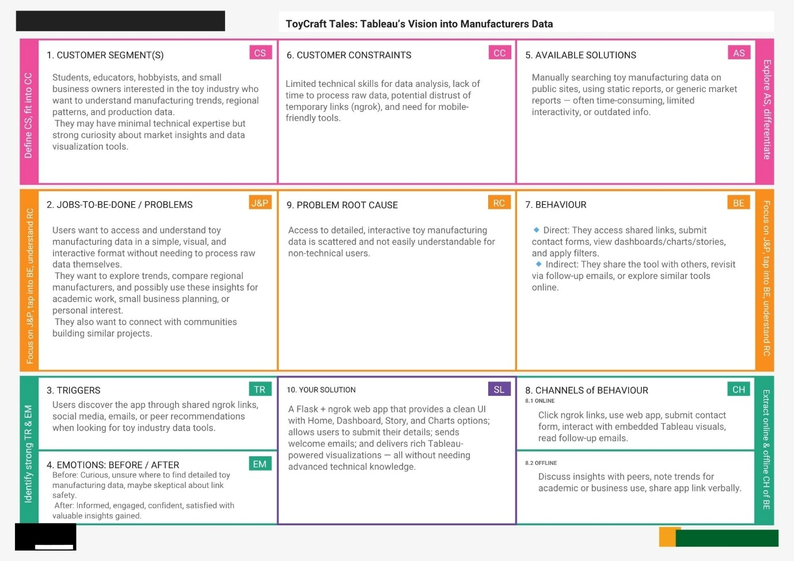

**4.2 Proposed Solution**

The proposed solution is a web-based application built using Flask that integrates with Tableau Public to provide interactive visualizations of toy manufacturing data. The platform is designed to be lightweight, requiring no installations or technical expertise from end users. It is accessible via a secure ngrok link, enabling easy sharing and public access without the need for full cloud deployment.

Key features of the solution include:

* A simple and intuitive user interface with navigation options for Home, Dashboard, Charts, and Story.
* Embedded Tableau dashboards, charts, and stories that allow users to interact with data through filters, tooltips, and scene navigation.
* A contact form that lets users submit their details to join the initiative, with submissions stored in a MySQL database.
* Automated welcome emails sent to users who provide valid email addresses via the form.
* Administrative capabilities to view, edit, or delete contact data and monitor server availability.

The solution ensures that non-technical users can gain valuable insights from complex datasets while supporting future enhancements and scalability.

|  |  |  |
| --- | --- | --- |
| **S.No.** | **Parameter** | **Description** |
|  | Problem Statement (Problem to be solved) | Users, especially students, educators, and small business owners, lack an easy way to access and understand toy manufacturing data. Existing data sources are scattered, static, and require technical skills to interpret. |
|  | Idea / Solution description | A Flask + ngrok-based web app with a clean UI that embeds Tableau dashboards, charts, and stories to provide interactive toy industry insights. It includes a contact form for community participation and sends welcome emails to valid users. |
|  | Novelty / Uniqueness | Combines open-source technologies (Flask, Tableau Public) to deliver focused toy manufacturing data visualizations without requiring complex setup or advanced analytics skills. Lightweight, accessible via shared link, no installation needed. |
|  | Social Impact / Customer Satisfaction | Empowers non-technical users to explore industry data easily, supporting education, small businesses, and hobbyists. Builds a sense of community through participation and feedback, enhancing satisfaction and engagement. |
|  | Business Model (Revenue Model) | Initially free as an educational tool; can evolve to offer premium insights, custom dashboards for businesses, or ad-free experiences. Potential for partnerships with toy industry stakeholders or educational institutions. |
|  | Scalability of the Solution | Designed for easy scaling — can move from ngrok + local server to cloud deployment (AWS, GCP, Azure) with microservices or 3-tier architecture. Additional data sources, APIs, or features can be integrated without major redesign. |

**4.3 Solution Architecture**

The *ToyCraft Tales* solution architecture is designed to deliver a seamless, interactive experience by integrating lightweight web technologies with cloud-based visualization tools.

**Key components of the architecture:**

* **User:** Accesses the application via a web browser using a public ngrok URL.
* **Web UI:** Built with HTML, CSS, Bootstrap, and Jinja2 templates, providing a clean interface with navigation to Home, Dashboard, Charts, and Story pages.
* **Flask Application:** Handles routing, form processing, validation, email sending, and Tableau embedding.
* **MySQL Database:** Stores contact form submissions securely.
* **SMTP Service:** Sends automated welcome emails for valid form submissions using Flask-Mail and SMTP.
* **Tableau Public:** Hosts dashboards, charts, and stories, which are embedded within the application for interactive data visualization.
* **Admin Interface:** Allows administrators to manage contact data and monitor server status.

**Data flow:**

* The user accesses the app and navigates between sections.
* Form submissions are processed by the Flask app, validated, and stored in MySQL.
* Valid emails trigger the SMTP service to send welcome emails.
* Tableau visualizations are embedded and rendered dynamically within the UI.

This architecture ensures ease of deployment, scalability, and an accessible user experience using open-source technologies.

**Architecture:**

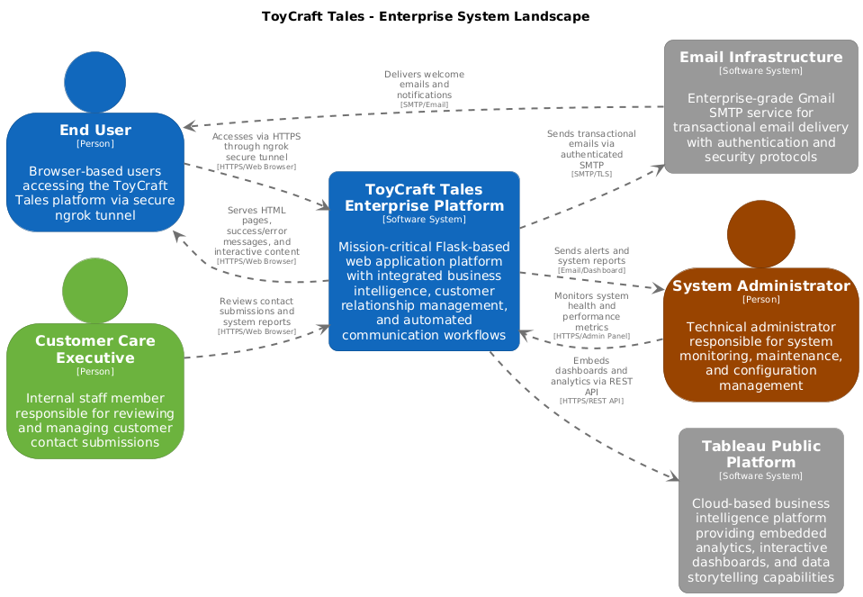

1. **PROJECT PLANNING & SCHEDULING**

The project planning and scheduling phase defined how the work was organized and executed across sprints. A product backlog was created with detailed user stories, story points, priorities, and sprint allocations. The planning focused on delivering core features in Sprint 1 and enhancements in Sprint 2, following an agile, iterative development process.

Clear sprint goals, story estimations, and velocity tracking ensured timely delivery of functional components and supported continuous improvements based on progress.

**5.1 Project Planning**

The project was managed using an agile methodology, executed across two sprints. Story points were assigned to each user story based on complexity and estimated effort, using the following scale:  
1 = Very Easy, 2 = Easy, 3 = Moderate, 5 = Difficult.

**Sprint 1 (5 Days): Core Functionality**

The first sprint focused on delivering the essential user-facing features:

* **Registration / Contact Form:**
  + USN-1: Access app via ngrok and navigate the UI (2 points)
  + USN-2: Fill contact form (name, email, phone) (2 points)
  + USN-3: Valid email triggers a welcome email (1 point)
  + USN-4: Invalid email results in no email sent and no data saved (1 point)
* **Dashboard:**
  + USN-5: Access dashboard and view visual insights (3 points)
* **Charts:**
  + USN-7: Access individual charts, such as manufacturers by year (2 points)
* **Story:**
  + USN-9: Access Tableau story with multiple scenes (2 points)

Total story points for Sprint 1: **13**

**Sprint 2 (2 Days): Enhancements**

The second sprint was dedicated to enhancements and refinements:

* **Dashboard:**
  + USN-6: Apply filters to refine data view (2 points)
* **Charts:**
  + USN-8: Interact with chart elements (hover/click) (2 points)
* **Story:**
  + USN-10: Navigate between story scenes and understand insights (2 points)

Total story points for Sprint 2: **6**

**Velocity Calculation**

* Total Story Points Completed: 13 (Sprint 1) + 6 (Sprint 2) = 19
* Number of Sprints: 2
* Velocity: 19 / 2 = 9.5 story points per sprint

**Summary**

The project plan ensured that all essential features were prioritized and delivered in the first sprint, while the second sprint focused on enhancements to improve the user experience. This agile approach enabled incremental delivery, clear prioritization, and efficient execution of both core functionality and subsequent improvements.

1. **FUNCTIONAL AND PERFORMANCE TESTING**

The functional and performance testing phase ensured that *ToyCraft Tales* met all defined requirements, worked reliably, and delivered a smooth user experience. Testing focused on verifying each user story, checking system behaviour under typical usage, and validating the integration of various components (Flask, MySQL, Tableau embeds, and email services).

Functional testing covered navigation, form handling, email delivery, dashboard interaction, chart and story functionality, and admin operations. Performance testing ensured the application responded efficiently to user actions, handled data rendering effectively, and maintained reliability during normal operations.

|  |  |  |
| --- | --- | --- |
| **S No.** | **Parameter** | **Screenshot / Values** |
|  | Data Rendered |  |
|  | Data Preprocessing | No any Preprocessing Required. |
| 3. | Utilization of Filters | Some of the utilization of filter as year is used here. |
| 4. | Calculation fields Used |  |
| 5. | Dashboard design | No of Visualizations / Graphs - 6 Visualizations |
| 6 | Story Design | No of Visualizations / Graphs - 6 Visualizations    It is the story |

1. **RESULTS**

The *ToyCraft Tales* project successfully delivered a lightweight, interactive platform for visualizing toy manufacturing data. The application met all functional requirements, including

form submissions, email notifications, and embedded Tableau visualizations. Users were able to explore market trends, production patterns, and regional data through the dashboard, charts, and story views.

**7 Output Screenshots**

**CHARTS**

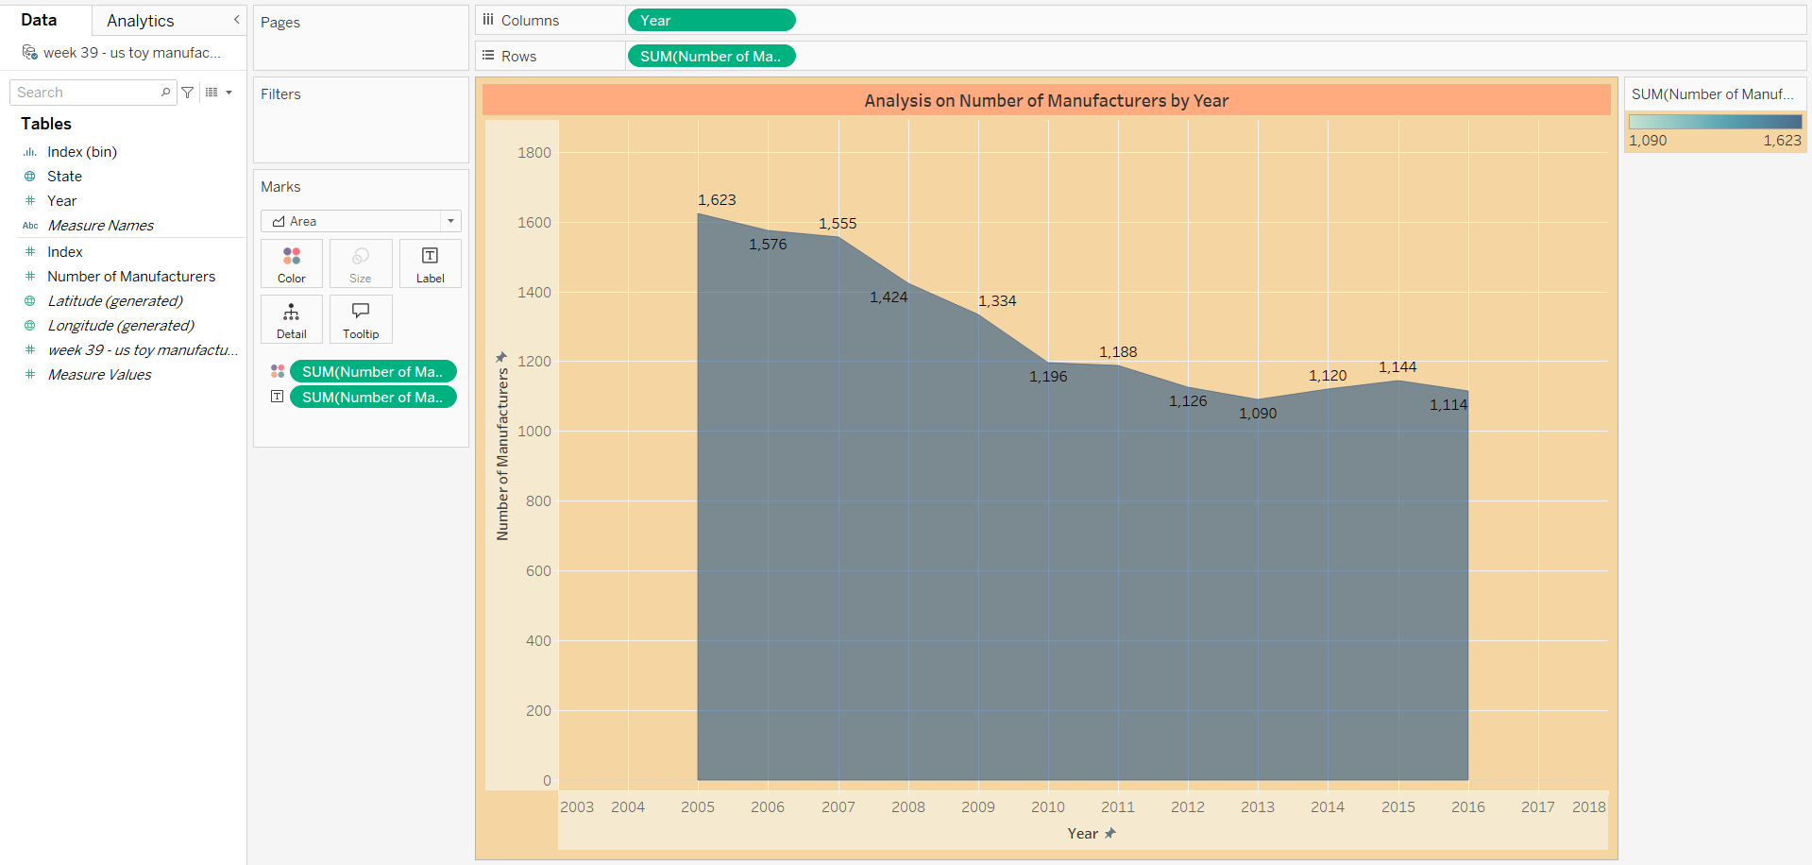

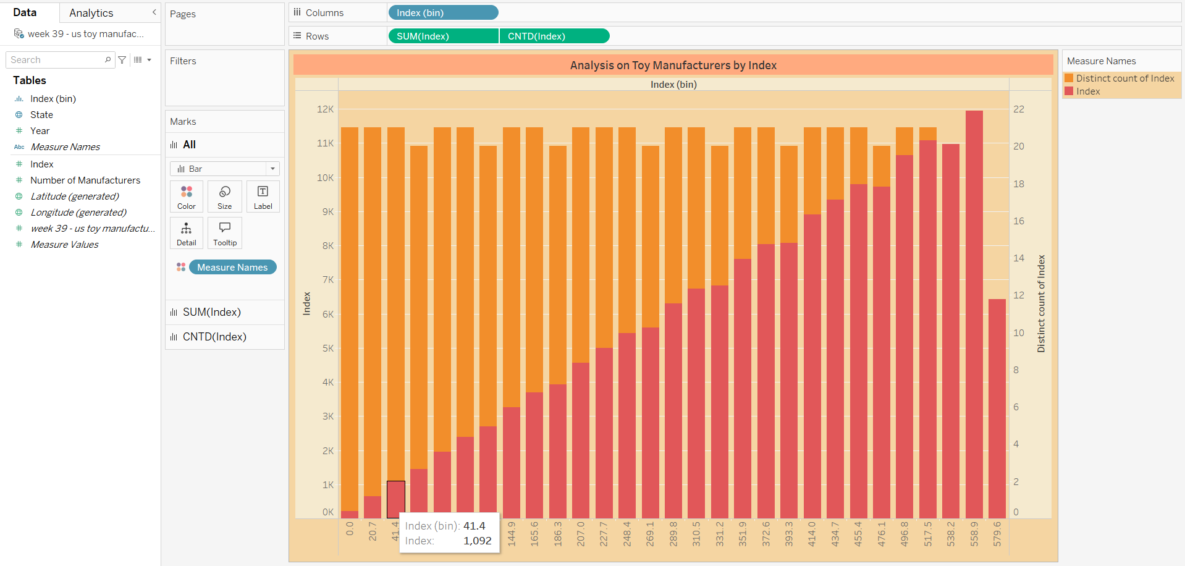

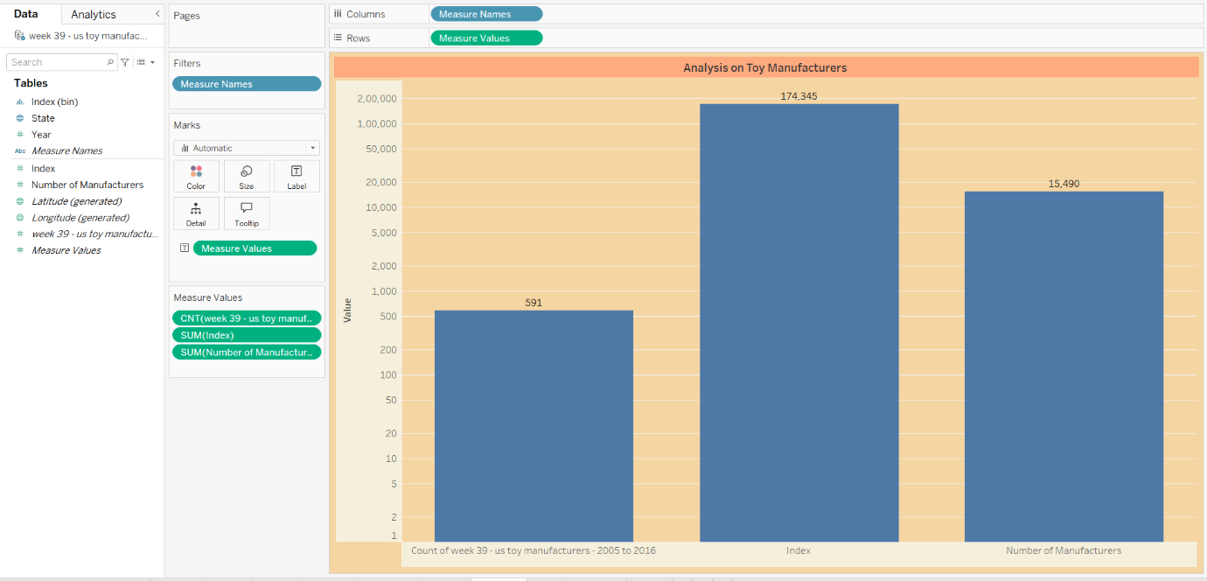

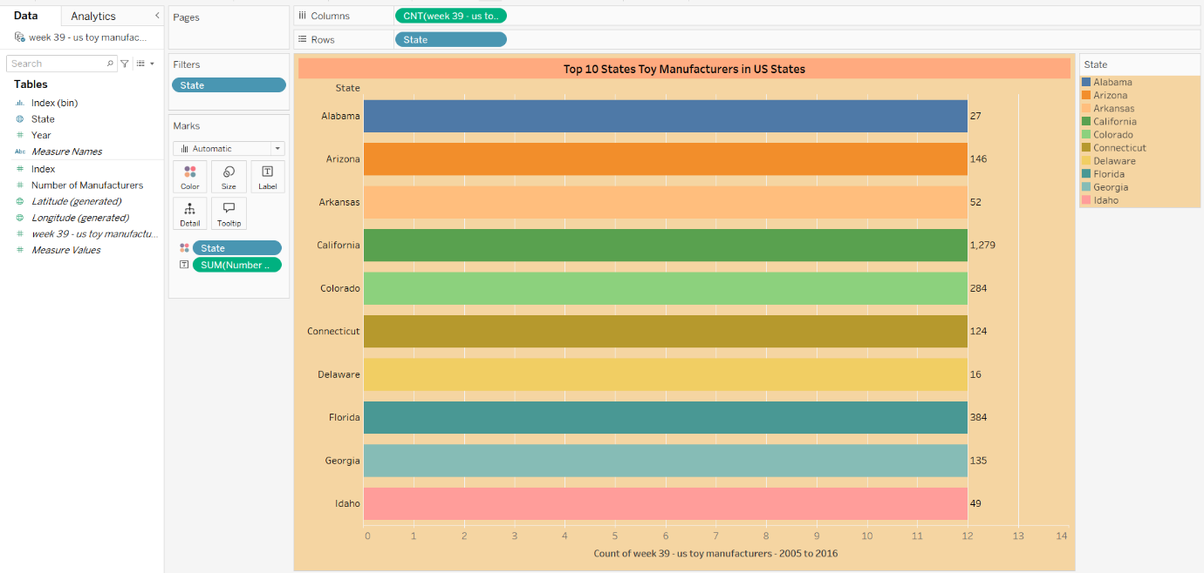

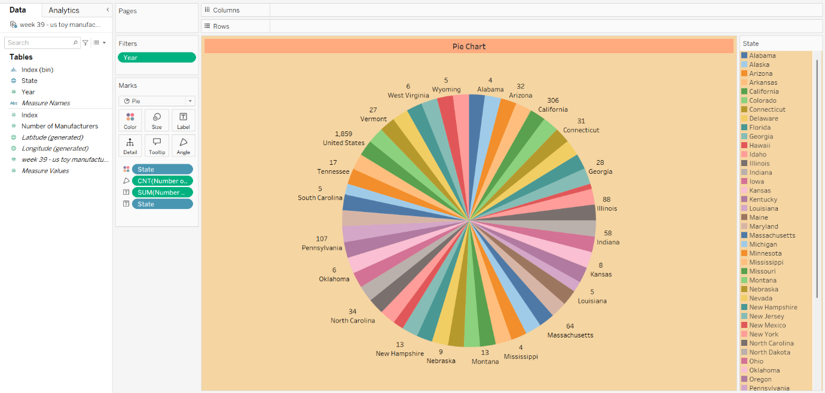

**DASHBOARD**

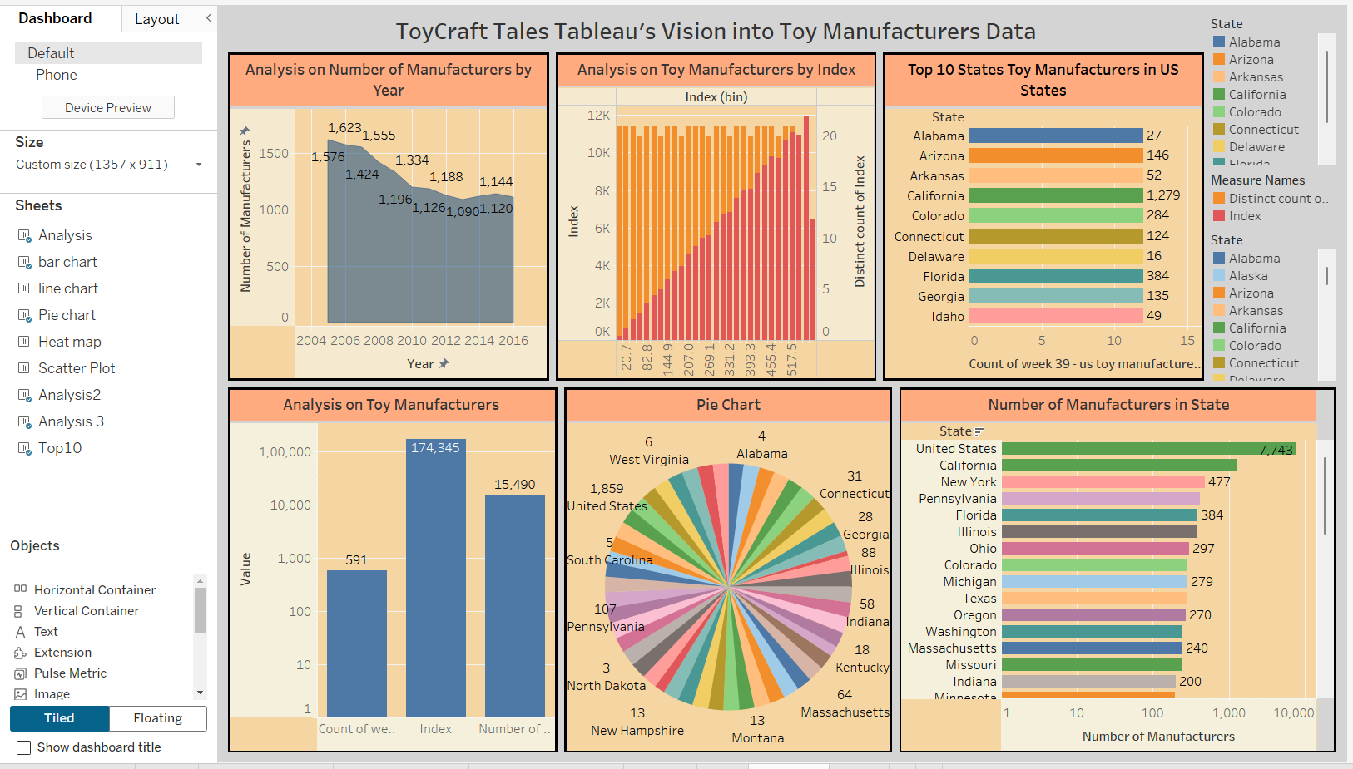

**STORY**

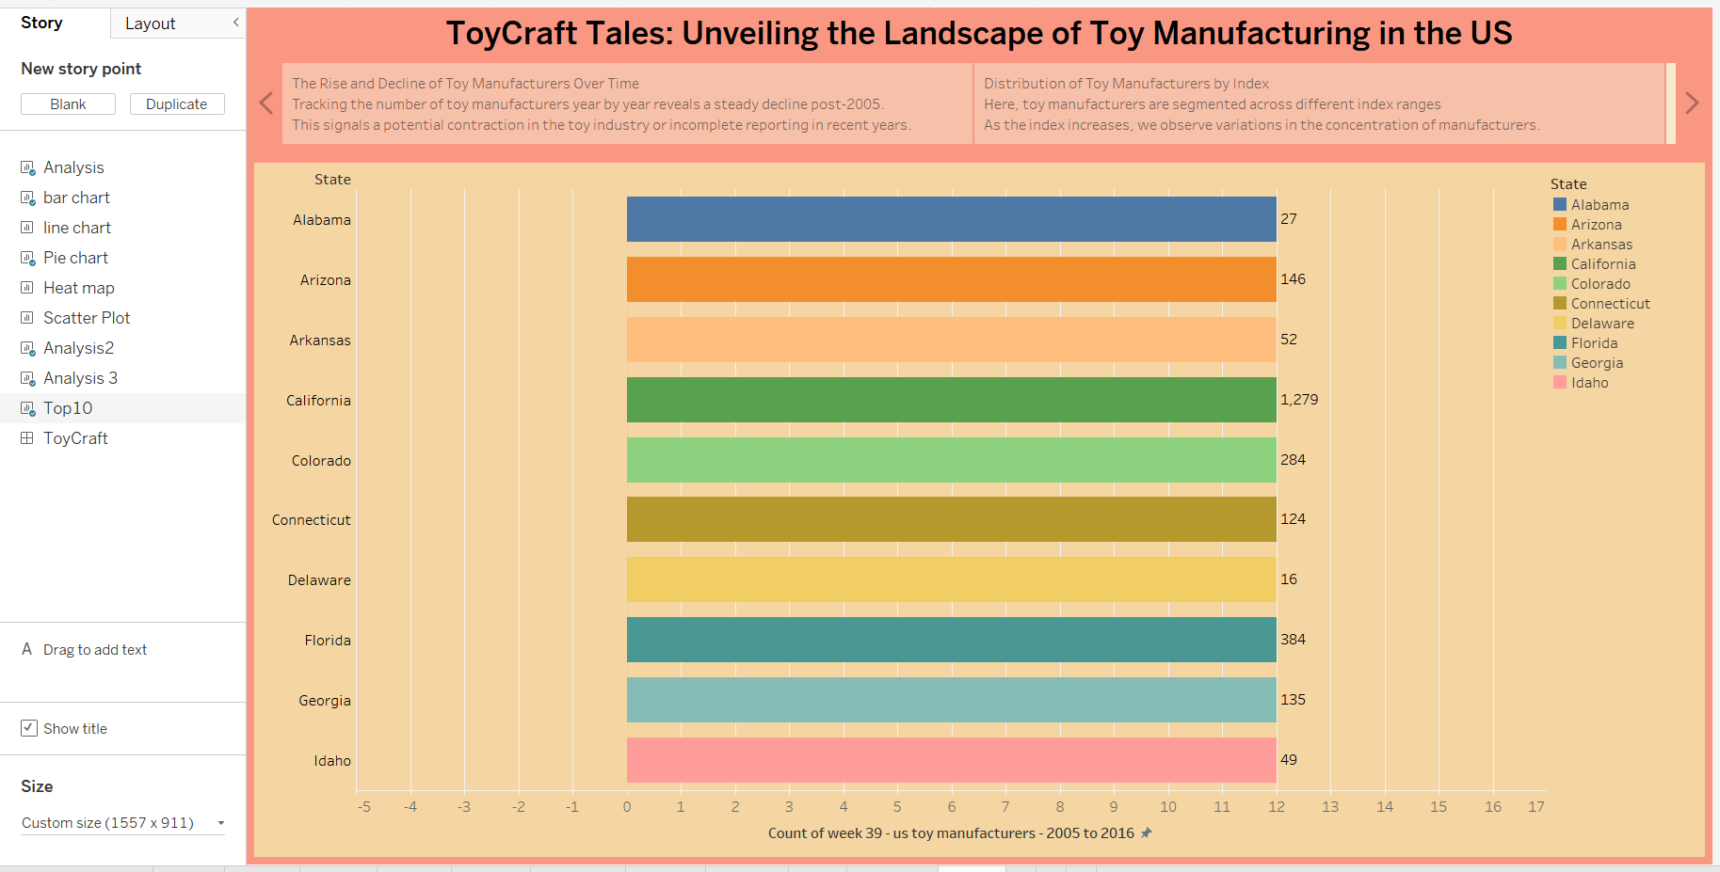

1. **ADVANTAGES & DISADVANTAGES**

**Advantages**

* The platform is lightweight and accessible via ngrok without requiring full cloud deployment.
* No installation or technical expertise is needed for end users to explore visualizations.
* The solution integrates powerful Tableau dashboards and charts to deliver rich, interactive insights.
* The technology stack uses mostly open-source and free tools, making it cost-effective and easy to maintain.
* Admin features allow secure management of user-submitted data and server monitoring.

**Disadvantages**

* Dependency on ngrok means the app’s availability is tied to the local server status and requires the server to remain running.
* Tableau Public limits certain customization and advanced features compared to premium versions.
* The platform is suitable for small to medium datasets, and may need enhancements for larger-scale deployments or high concurrent usage.

1. **CONCLUSION**

*ToyCraft Tales* successfully demonstrates how open-source tools and cloud-based visualization platforms can be combined to deliver an accessible, interactive solution for data exploration. The project achieved its goal of transforming toy manufacturing data into meaningful insights through intuitive dashboards, charts, and stories, helping users understand market trends, production patterns, and regional distributions without needing technical expertise.

The application provided a lightweight, browser-based interface that allowed users to navigate visualizations easily and interact with data in real time. The use of Tableau Public enabled rich, interactive visual elements, while Flask and ngrok offered a flexible way to serve and share the app without complex deployment requirements. The inclusion of a contact form, automated welcome emails, and admin features added community-building and management capabilities to the platform.

Overall, the project successfully delivered a functional, user-friendly, and cost-effective tool that bridges the gap between complex datasets and non-technical audiences. The work done provides a strong foundation for future development, where features such as full cloud deployment, enhanced scalability, real-time data updates, and deeper analytical capabilities can further enrich the user experience.

**10. FUTURE SCOPE**

The *ToyCraft Tales* platform provides a solid base for further enhancements and expansion. Several opportunities exist to improve its functionality, scalability, and impact:

* **Cloud deployment:** Moving from ngrok and local hosting to full cloud deployment (e.g., AWS, Azure, or GCP) would ensure continuous availability, better scalability, and enhanced security.
* **Real-time data integration:** Future versions could connect directly to live data sources or APIs, allowing users to explore up-to-date toy manufacturing trends.
* **Advanced analytics:** Incorporating predictive analytics, machine learning models, or custom Tableau calculations could provide deeper insights beyond static visualizations.
* **User authentication and personalization:** Adding secure user login and personalized dashboards would enhance user experience and data privacy.
* **Mobile optimization:** Enhancing responsiveness and usability on mobile devices to improve accessibility for users on the go.
* **Community features:** Expanding the contact form into a community portal where users can share insights, discuss trends, and collaborate on analyses.

These future developments would extend the platform’s usefulness, attract a broader audience, and support richer data exploration and decision-making.

**11. APPENDIX**

**Source Code (if any):**  
The source code for *ToyCraft Tales* is developed using Python (Flask) and related technologies. The code is maintained in a GitHub repository for review, updates, and potential future enhancements.  
*GitHub Repository Link:* [[github](https://github.com/g-chandra-sekhar-reddy/Tableau-s-Vision-into-Toy-Manufacturer-Data-final)]

**Dataset Link:**  
The toy manufacturing dataset used for this project is sourced from open datasets or mock data prepared for visualization purposes.  
*Dataset Link:*

Toy Manufacturers in US States | Kaggle.

Toy Manufacturer Data by State and Year.

<https://www.kaggle.com/datasets/thedevastator/toy-manufacturers-in-us-states?select=Week+39+-+US+Toy+Manufacturers+-+2005+to+2016.hyper>

**GitHub & Project Demo Link:**

* *GitHub Repository:* [[github](https://github.com/g-chandra-sekhar-reddy/Tableau-s-Vision-into-Toy-Manufacturer-Data-final)]
* *Project Demo (ngrok link or video demo link):*[[DEMO LINK](https://drive.google.com/file/d/1ygGVlycK76fXgiDV-Xo4OIFUVHWjnMRJ/view?usp=sharing)]